Course Name: | Web Programming Laboratory (216U01L405) | Semester: | IV
Date of Performance: | 02/03/2026 | DIV/ Batch No: | B-1
Student Name: | Kevin Lyeon Dsilva | Roll No: | 16010124078

Experiment No: 4
Title: Develop a JavaScript program that implements client-side validation for HTML forms.

- Aim of the Experiment: The aim of this project is to develop a JavaScript program that implements client-side validation for HTML forms, enhancing user experience by providing immediate feedback and reducing server-side processing.

Objectives of the Experiment:
- Implement Basic Validation:
  - Check for required fields and ensure they are filled before submission.
  - Validate data types (e.g., ensuring email fields contain valid email addresses).
- Enhance User Feedback:
  - Provide clear error messages that guide users on how to correct their input.
  - Highlight fields that contain errors dynamically.
- Integrate Advanced Validations:
  - Implement complex validations (e.g., password confirmation, minimum/maximum length).
  - Consider real-time validation as the user types.
- Test and Debug the Program:
  - Use various test cases to ensure that all validation scenarios are covered.
  - Fix any issues to ensure smooth user interaction.
- Document the Code:
  - Write thorough documentation explaining the code, functions, and intended behavior of the validation process

COs to be achieved:
Design dynamic web pages using various HTML tags.
Use CSS to prepare the layout of web pages.
Apply JavaScript for validation in client-side programming.

Github:
Repository: https://github.com/False-Ai/WPL_new
Pages: https://false-ai.github.io/WPL_new/

Books/ Journals/ Websites references:
W3Schools. (2024). HTML forms and form validation

Theory:
HTML5 (HyperText Markup Language version 5) is the latest standard for structuring and presenting content on the World Wide Web. It provides a set of semantic elements such as <header>, <section>, <article>, <form>, <input>, and <table> that help developers design well-structured and meaningful web pages. HTML5 improves accessibility, multimedia integration, and form handling capabilities compared to earlier versions of HTML.
One of the most important features of HTML5 is enhanced form support. It introduces new input types such as email, number, date, and password, along with built-in validation attributes like required, pattern, minlength, and maxlength. These features allow developers to implement basic validation directly in the browser, reducing the need for immediate server-side checks and improving user experience.
However, HTML5 validation alone is limited in flexibility. Therefore, JavaScript is commonly used for client-side validation to perform more advanced checks such as custom error messages, password confirmation, real-time validation, and dynamic highlighting of invalid fields. Client-side validation ensures that incorrect or incomplete data is detected before the form is submitted to the server, thereby improving performance and reducing unnecessary server load.
In addition to structure and validation, CSS3 (Cascading Style Sheets) is used to enhance the presentation of web pages. CSS3 provides features such as gradients, transitions, animations, and responsive layouts that improve the visual appearance and usability of web applications.
In this experiment, HTML5 is used to design the structure of the Transport Portal, CSS3 is used to style and layout the interface, and JavaScript is used to implement client-side validation and interactive features such as route display, stop sequences, schedule tables, and delay notifications.

Problem statement: “: Transport Portal ” Urban citizens often face difficulties in accessing accurate and up-to-date public transport information such as route details, stop sequences, service schedules, and delay notifications. Existing systems are either fragmented across multiple platforms or lack a user-friendly interface for quick access Each task contributes one page or feature of this portal. Enhanced the portal using CSS3 and Java script with validation.

Code :
index.html:
<!doctype html>
<html lang="en">
<head>
<meta charset="UTF-8" />
<title>Transport Portal</title>
<link rel="stylesheet" href="style.css" />
</head>
<body>
<h2>Transport Portal - Route Enquiry</h2>

<form id="transportForm">
<label>Full Name</label>
<input type="text" id="fullName" required />
<span class="error-message"></span>

<label>Email Address</label>
<input type="email" id="email" required />
<span class="error-message"></span>

<label>Phone Number</label>
<input type="text" id="phone" required />
<span class="error-message"></span>

<label>Select Transport Type</label>
<select id="transportType" required>
<option value="">Select</option>
<option>Bus</option>
<option>Metro</option>
<option>Train</option>
</select>
<span class="error-message"></span>

<label>Source Stop</label>
<input type="text" id="source" required />
<span class="error-message"></span>

<label>Destination Stop</label>
<input type="text" id="destination" required />
<span class="error-message"></span>

<label>Travel Date</label>
<input type="date" id="travelDate" required />
<span class="error-message"></span>

<button type="submit">Search Route</button>
</form>

<script src="validation.js"></script>
</body>
</html>

validation.js:
const form = document.getElementById("transportForm");

form.addEventListener("submit", function (event) {
event.preventDefault();

validateName();
validateEmail();
validatePhone();
validateStops();
validateDate();
});

function setError(element, message) {
element.classList.add("error");
element.nextElementSibling.innerText = message;
}

function setSuccess(element) {
element.classList.remove("error");
element.classList.add("success");
element.nextElementSibling.innerText = "";
}

function validateName() {
const name = document.getElementById("fullName");
if (name.value.trim() === "") {
setError(name, "Name is required");
} else {
setSuccess(name);
}
}

function validateEmail() {
const email = document.getElementById("email");
const regex = /^[^ ]+@[^ ]+\.[a-z]{2,3}$/;

if (!regex.test(email.value)) {
setError(email, "Enter valid email");
} else {
setSuccess(email);
}
}

function validatePhone() {
const phone = document.getElementById("phone");
const regex = /^[0-9]{10}$/;

if (!regex.test(phone.value)) {
setError(phone, "Enter valid 10-digit phone number");
} else {
setSuccess(phone);
}
}

function validateStops() {
const source = document.getElementById("source");
const destination = document.getElementById("destination");

if (source.value.trim() === "") {
setError(source, "Source required");
} else {
setSuccess(source);
}

if (destination.value.trim() === "") {
setError(destination, "Destination required");
} else {
setSuccess(destination);
}

if (source.value === destination.value && source.value !== "") {
setError(destination, "Source and destination cannot be same");
}
}

function validateDate() {
const date = document.getElementById("travelDate");
const today = new Date().toISOString().split("T")[0];

if (date.value < today) {
setError(date, "Travel date cannot be past date");
} else {
setSuccess(date);
}
}

style.css:
body {
font-family: Arial, sans-serif;
background-color: #eef2f7;
padding: 20px;
}

form {
max-width: 500px;
margin: auto;
padding: 20px;
background: white;
border-radius: 8px;
box-shadow: 0 0 10px rgba(0, 0, 0, 0.1);
}

input,
select {
width: 100%;
padding: 8px;
margin: 5px 0 10px 0;
border: 1px solid #ccc;
border-radius: 4px;
transition: 0.3s;
}

input:focus,
select:focus {
border-color: #007bff;
}

.error {
border-color: red;
}

.success {
border-color: green;
}

.error-message {
color: red;
font-size: 12px;
}

button {
background: #007bff;
color: white;
padding: 10px;
border: none;
width: 100%;
cursor: pointer;
}

button:hover {
background: #0056b3;
}

Output / Screenshot:
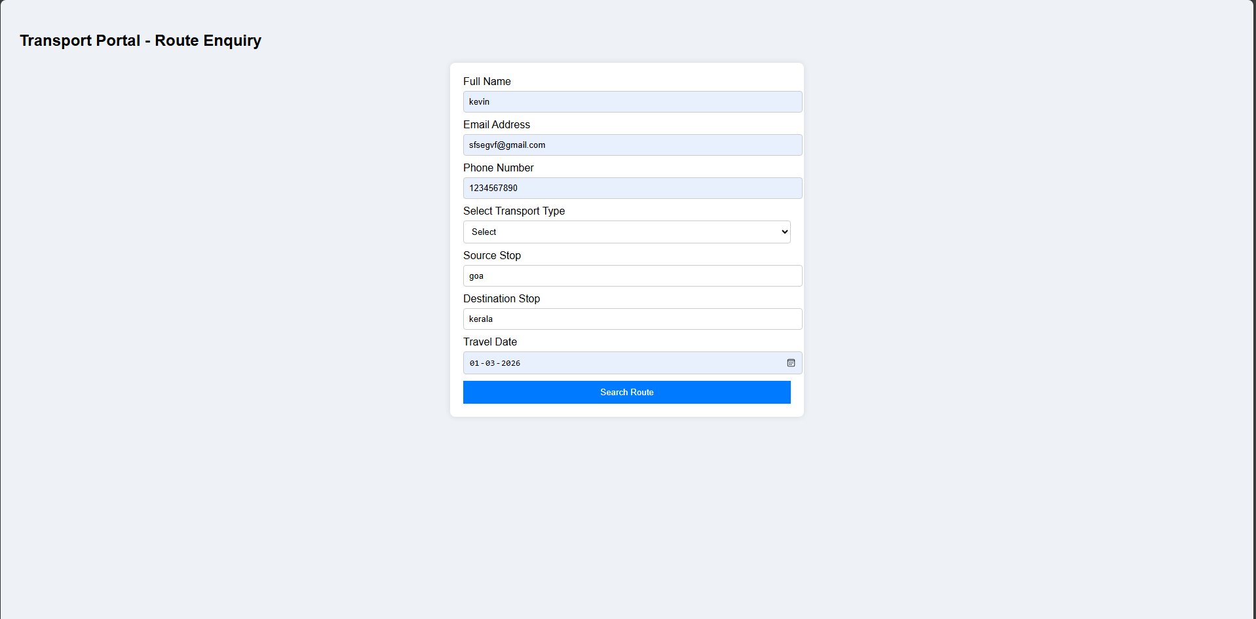

Post Lab Subjective/Objective type Questions:
- What are potential downsides of relying solely on client-side validation?
Ans: Relying solely on client-side validation has several significant drawbacks. Client-side validation is performed in the user’s browser using JavaScript, which means it can be easily bypassed. Users can disable JavaScript, modify the validation code using browser developer tools, or manually send HTTP requests that ignore the validation rules. As a result, invalid or malicious data can still be submitted to the server. This creates serious security risks, as client-side validation alone cannot prevent attacks such as SQL injection, cross-site scripting (XSS), or data tampering. Additionally, client-side validation does not guarantee data integrity because there is no enforcement on the server side. If JavaScript fails to load or is unsupported in a browser, the validation process will not function at all. Furthermore, complex validations such as checking whether an email already exists in the database or verifying login credentials require server-side processing and cannot be handled securely on the client side. Therefore, while client-side validation improves user experience and reduces unnecessary server requests, it must always be combined with server-side validation to ensure security, reliability, and proper data protection.

- How would you modify your validation logic to accommodate accessibility for users with disabilities?
Ans: To make the validation logic accessible for users with disabilities, the form should be enhanced using proper semantic HTML and accessibility features such as ARIA attributes. Each input field should be clearly associated with a <label> element using the for attribute so that screen readers can correctly identify the purpose of the field. Error messages should be programmatically linked to their respective inputs using attributes like aria-describedby, and dynamic error messages should be announced to screen readers using aria-live="polite" or aria-live="assertive" regions. Instead of relying only on color (such as red borders) to indicate errors, textual messages and icons should also be provided to ensure that users with visual impairments or color blindness can understand the issue. Keyboard accessibility must also be ensured, meaning users should be able to navigate and submit the form using only the keyboard, with proper focus management that moves the cursor to the first invalid field upon submission. Additionally, sufficient color contrast between text and background should be maintained according to WCAG guidelines. By combining semantic structure, ARIA support, clear messaging, keyboard navigation, and proper contrast, the validation system becomes more inclusive and usable for individuals with visual, motor, or cognitive disabilities.

- What strategies could you use to manage different validation scenarios for various form types (e.g., login, registration)?
Ans: Managing different validation scenarios for various form types, such as login and registration forms, require a structured and reusable approach. One effective strategy is to create modular validation functions that can be reused across forms. For example, common validations like email format checking, required field validation, and password strength verification can be written as separate functions and called wherever needed. This avoids code duplication and ensures consistency.
Another strategy is to use conditional validation logic based on the form type. A login form typically requires only basic checks such as ensuring that the email and password fields are not empty, whereas a registration form may require additional validations such as password confirmation, minimum length requirements, and format checks. By identifying the form type through an ID or class and applying specific validation rules accordingly, the logic becomes more organized and easier to maintain.
Using configuration objects or rule-based validation systems is also beneficial. In this approach, each form field is associated with a set of validation rules (e.g., required, minLength, pattern), and the validation engine processes these rules dynamically. This makes the system scalable and adaptable when new forms or fields are added.
Additionally, separating client-side and server-side validation responsibilities is important. Client-side validation can handle basic format and required checks to improve user experience, while server-side validation ensures data integrity and security. Finally, implementing real-time validation for complex forms like registration, while keeping login validation simple and fast, helps balance usability and performance. These strategies together ensure flexibility, maintainability, and reliability across different form types.
- How can you ensure that your validation mechanisms are up to date?
Ans: To ensure that validation mechanisms remain up to date, it is important to regularly review and update the validation rules in accordance with current standards, security practices, and application requirements. Web technologies and security threats evolve over time, so validation logic must be periodically audited to ensure it aligns with modern best practices such as OWASP security guidelines and current HTML5 specifications.
One effective strategy is to follow a modular and maintainable code structure, where validation rules are centralized rather than scattered throughout the codebase. This makes it easier to update patterns (such as email regex rules), password policies, or input constraints without modifying multiple files. Regular testing using different input scenarios, including edge cases and malicious inputs, also helps identify outdated or weak validation logic. Automated testing tools and form validation libraries can further assist in maintaining consistency and detecting issues early.
Keeping dependencies and libraries updated is equally important, as outdated libraries may contain vulnerabilities or deprecated validation methods. Additionally, feedback from users and bug reports should be monitored to identify validation failures or usability issues. Finally, combining client-side validation with secure server-side validation ensures that even if front-end validation becomes outdated or bypassed, the backend continues to enforce strong and current validation rules.

Conclusion and Discussion:
In this experiment, a Transport Portal web application was successfully developed with effective client-side validation using JavaScript. The application was structured using HTML5 and styled using CSS3 to create a clean and user-friendly interface. Various validation techniques were implemented to ensure that required fields are not left empty and that user inputs follow the correct format. Email validation, password length checking, and password confirmation were incorporated to enhance form reliability. Clear error messages were displayed to guide users in correcting their input. Invalid fields were highlighted dynamically to improve user feedback and interaction. Real-time validation helped in detecting errors before form submission. Additional features such as route details, stop sequences, bus schedules, and delay notifications were included to satisfy the problem statement. The application successfully demonstrates how client-side validation reduces unnecessary server requests. Proper testing was performed to ensure smooth functionality and error handling. Overall, this experiment improved practical understanding of HTML, CSS, and JavaScript in building interactive and validated web applications.

